Sample CPQ&R Graphics

These figures provide suggestions for graphically illustrating key policy questions associated with high-quality preschool programs using the CPQ&R calculator. To create your own graphs, please visit the CEELO webpage and click on User Guide.
Example 1: Per Child Costs
High-quality early education benefits all children. The CPQ&R calculator can help you show policymakers the investment needed on a per-child bases to enhance quality in specific ways, such as enhancing teacher degree requirements, reducing class size and increasing dosage.

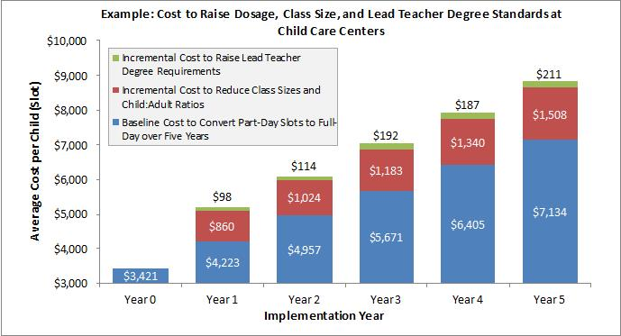

Example 2: Teacher Salaries & Benefits
High-quality pre-k is one of the best investments we can make with public dollars—and teachers are key. The CPQ&R calculator can help you illustrate teacher salary and benefits, often the greatest investment for any pre-K program.

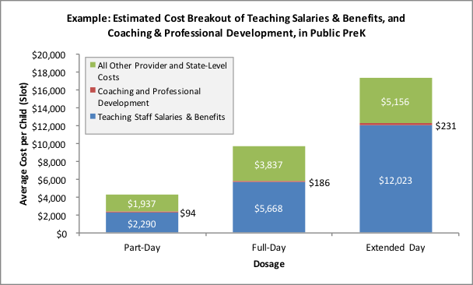

Example 3: Average Spending per Child
Studies show rates of return exceeding costs for every dollar invested in high-quality pre-K and that dosage greatly affects child outcomes. The CPQ&R calculator can help you explain how spending per child varies by the length of day the child attends a program.

Example 4: Costs of Increasing Pre-K Teacher Credential Requirements
Teaching pre-K requires specialized skills to help each child learn and grow. The CPQ&R calculator can help you show policymakers the financial investment needed to enhance teacher credential requirements.

Example 5: Per Child Cost Based on Class Size, Student-Teacher Ratio
Young learners need small classes and one-on-one time with teachers. The CPQ&R calculator can help you illustrate the investment needed to reduce class size and student-to-teacher ratios.

